12/10/18

Remote access VPN-AnyConnect

Cisco CCNAS Period 5

Purpose:

This lab is a very practical lab, as where it can be used anywhere at any time. It’s a very important security implement for businesses for protection against data hack and loss. Remote access VPN is slightly different from Site-to-Site VPN. Were Site to Site is a secure connection between two company’s routers for security between two established locations. On the other hand, you have Remote access VPN, where you can be anywhere with internet connection and be able to browse the web securely with your own VPN.

Background:

Remote access VPN had a few drops here and there, where we needed to research things about Split Tunneling and referring to applications and software such as Cisco AnyConnect. AnyConnect is a software that allows us to VPN through a set ASA with Remote access VPN setup on it to allow our traffic to be encrypted when accessing the public web. Split Tunneling allowed us to be able to connect to a public domain such as the internet and a local WAN or LAN simultaneously. The Wizard on the ASA allowed us to set up a Remote access VPN quite efficiently with only a few bumps. When the Remote access VPN is setup, it works like a secret message writer. First, the information you are trying to send out to the public network is sent to the VPN server you have connected to, then it will encrypt and send your information out from the VPN server, so the information looks like it’s coming from another place, successfully blocking anyone who wants to steal or track your information.

Lab Setup:

Simple setup: Cisco AnyConnect mobility client, 1 Cisco 2901 router, 1 Cisco 5505 ASA, and 2 Computers (one connected to the router and one on the inside interface of the ASA)

Topology:

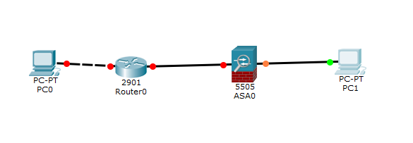

ASA configurations:

Crypto ca Certificate chain Jeffs-vpn-Cert

<Encrypted Output Too Long>

dhcpd auto_config outside

threat-detection basic-threat

threat-detection statistics access-list

no threat-detection statistics tcp-intercept

ssl trust-point Jeffs-vpn-Cert outside

ssl trust-point Jeffs-vpn-Cert inside

webvpn

enable inside

enable outside

anyconnect image disk0:/anyconnect-win-2.0.0343-k9.pkg 1

anyconnect enable

tunnel-group-list enable

group-policy GroupPolicy_SSL_VPN internal

group-policy GroupPolicy_SSL_VPN attributes

wins-server value 8.8.8.8

dns-server value 8.8.8.8

vpn-tunnel-protocol ssl-client

split-tunnel-network-list value VPNACL

default-domain value cisco.com

username jeffrey password F.se0xFQ7j.paL/Y encrypted

tunnel-group SSL_VPN type remote-access

tunnel-group SSL_VPN general-attributes

address-pool VPN_Pool

address-pool Net_Range

default-group-policy GroupPolicy_SSL_VPN

tunnel-group SSL_VPN webvpn-attributes

group-alias SSL_VPN enable

interface Vlan1

nameif inside

security-level 100

ip address 10.14.0.1 255.255.255.0

interface Vlan2

nameif outside

security-level 0

ip address 172.16.10.1 255.255.255.0

ip local pool VPN_Pool 10.14.0.5-10.14.0.20 mask 255.255.255.0

ip local pool Net_Range 15.0.0.1-15.0.0.10 mask 255.255.255.0

route outside 192.168.1.2 255.255.255.255 172.16.10.2

Fixup protocol icmp

Fixup Protocol icmp Error

Router Configurations:

Basic router Configurations such as ip address:

<Omitted for it is redundant>

Screen Shots:

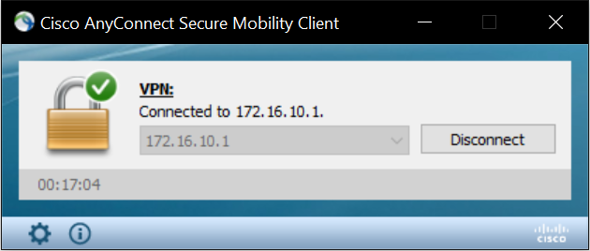

This is the AnyConnect Client working and connected to my ASA’s external IP Address

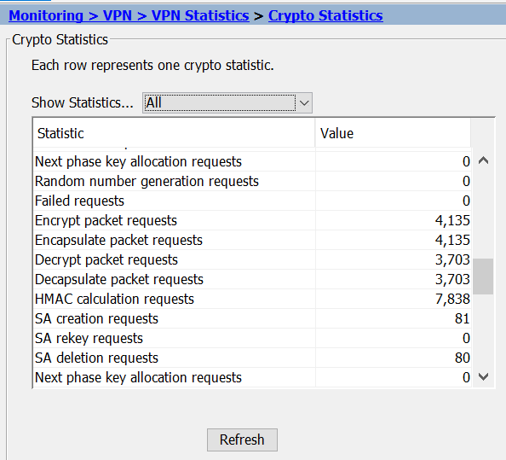

This is the Monitoring on the Cisco ASA where it tells us how many packets have been encapsulated or encrypted and decrypted.



This is the SSL client that I made on the ASA with the Wizard.

Problems:

I didn’t run into many harsh problems, only minor bumps such as forgetting to turn off my Wi-Fi so that my computer could ping using my Ethernet instead of the Wi-Fi card. Another slight problem I was having was when I forgot how to setup a proper route on the Cisco ASA so it would send information to the next hop ip address.

Conclusion:

I feel like this type of VPN was much more user friendly to set up, although both of the VPN’s have their own benefits and uses in different situations, Remote access VPN seems more useful on a day to day basis and could apply to many situations that are in need of a VPN.